Solution Document—TMA-01 M250 – Kelvin Rankin – PI: I4314904

Question 1

/**
* Question 1
* (a) Below is a short description of the SafeState Class.
* The SafeState class represents the state of a safe.

* (a) Below I added my name and the date i started TMA01.
* @author (Kelvin Rankin)
* @version (06/12/2023)
*/
// (a) Below is the SafeState class.
public class SafeState
{
// (b) Below i added 4 fields (3 Strings and 1 boolean).
private String userCode;
private String masterCode;
private String display;
private boolean open;

/**
(c) Constructor for the class SafeState.
*/
public SafeState()
{
// (c) 4 fields with default values taken from TMA01 (4 Strings)
this.userCode = null;
this.masterCode = "999999";
this.display = "WELCOME";
this.open = true;
}
// (d) Added 2 methods to the SafeState class.
// (d) Below is adding a getter method for the display field called getDisplay
public String getDisplay()
{
return display;
}
// (d) Below is adding a getter method for the open field called isOpen
public boolean isOpen()
{
return open;
}
// (e) Added a method with header public boolean open
// this method takes a string and check if it is
public boolean open(String aCode)
{
if (open)
{
display = "ALREADY OPEN";
return open;
}
else
{
if (aCode.equals(userCode) || aCode.equals(masterCode))
{
open = true;
display = "OPEN";
userCode = null;

}
else
{
display = "INVALID CODE";
}
}
return open;
}
// (f) Added a method with header public boolean public boolean.
public boolean isValidUserCode(String aCode)
{
if (aCode.length() == 4)
{
for(char c : aCode.toCharArray())
{
if (c < '0' || c > '9')
{
return false;
}
}
return true;
}
return false;
}
// (g) Added a public method lock that recieves a string as an argument.
public boolean lock(String aCode)
{
if (!open)
{
display = "ALREADY LOCKED";
return !open;
} else
{
if (isValidUserCode(aCode))
{
open = false;
display = "LOCKED";
userCode = aCode;
} else
{
display = "INVALID CODE";
}
}
return !open;
}
// (h) Added a method - about, This method takes no parameters it returns
// a string stating if the safe is already locked, already open or will
// give invalid code.
public String about()
{
return "Safe " + display;
}
}

Notes Question 1

I had many syntax errors and very easy to fix problems but took a long time to fix some of them mainly spelling errors and indentation errors, I used python quite a bit before so some of the syntax errors were due to writing the code with a python mindset mainly adding capital letters or not adding them was a problem.

I found the blue j IDE pretty slow and unresponsive sometimes also it was not indenting correctly on a new line which was frustrating having to use the back key quite a bit to line up code perhaps there is a shortcut I have not read about to make quality of life better on the IDE I tried looking online for a keyboard shortcut cheat-sheet as I know using keyboard is the way to go with coding for maximum efficiency.

For question one I was getting this error on the check with the test-bed website, it was a problem with the way I had wrote the about method I had wrote

public String about()
{
return "Safe" + display;
}

To fix this I simply put a space after Safe, this problem held me back for a while because I could not figure out what was wrong but it is such a silly mistake. The corrected version is below.

public String about()
{
return "Safe " + display;
}
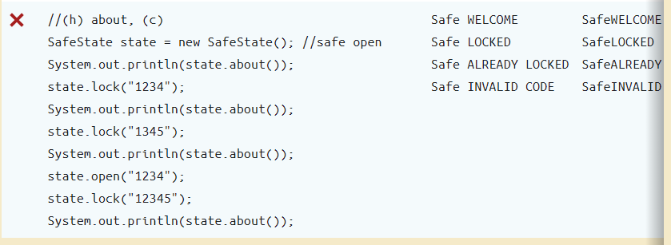

After fixing syntax errors and indentation errors I was able to get all green on everything which I was very happy with but I was disappointed on how long it took me to recognise the problems I am hoping with time I will be able to spot problems quicker and improve my code.
